# Is Defective

Combined (1:1, pytorch/tensorflow)

## Heatmap (Pearson)

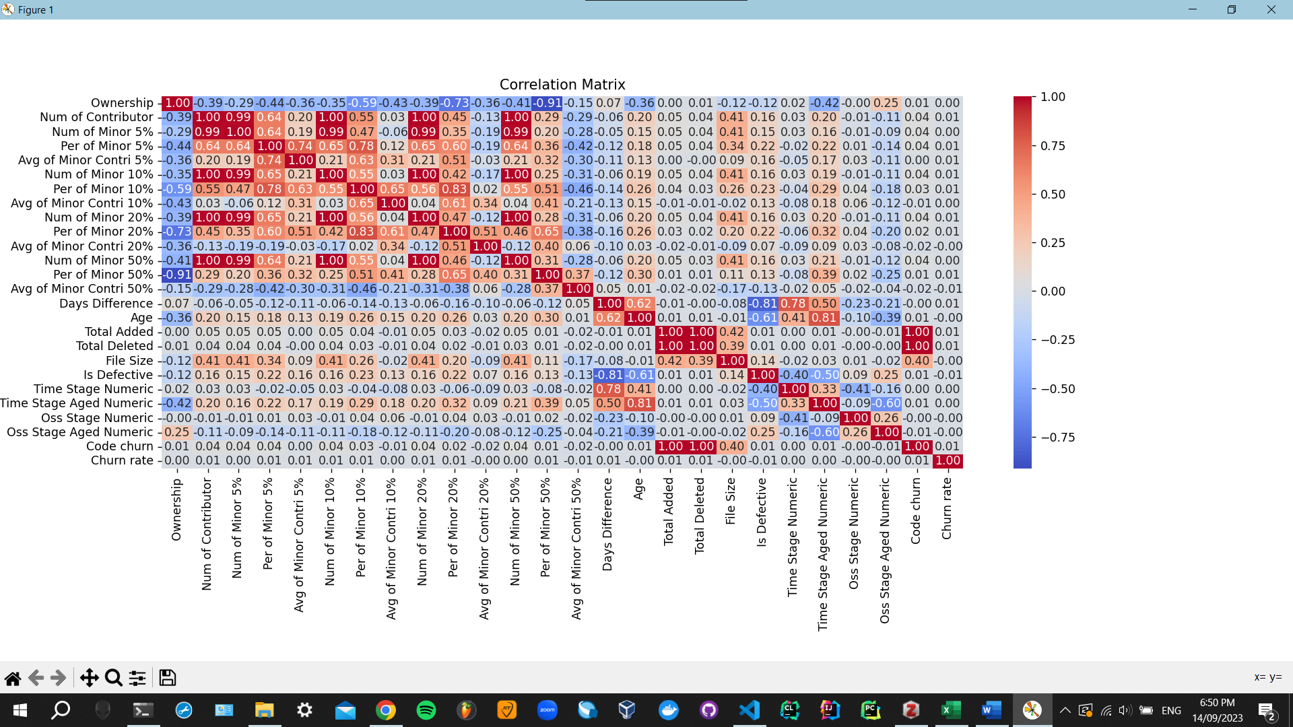

## Heatmap (Spearman)

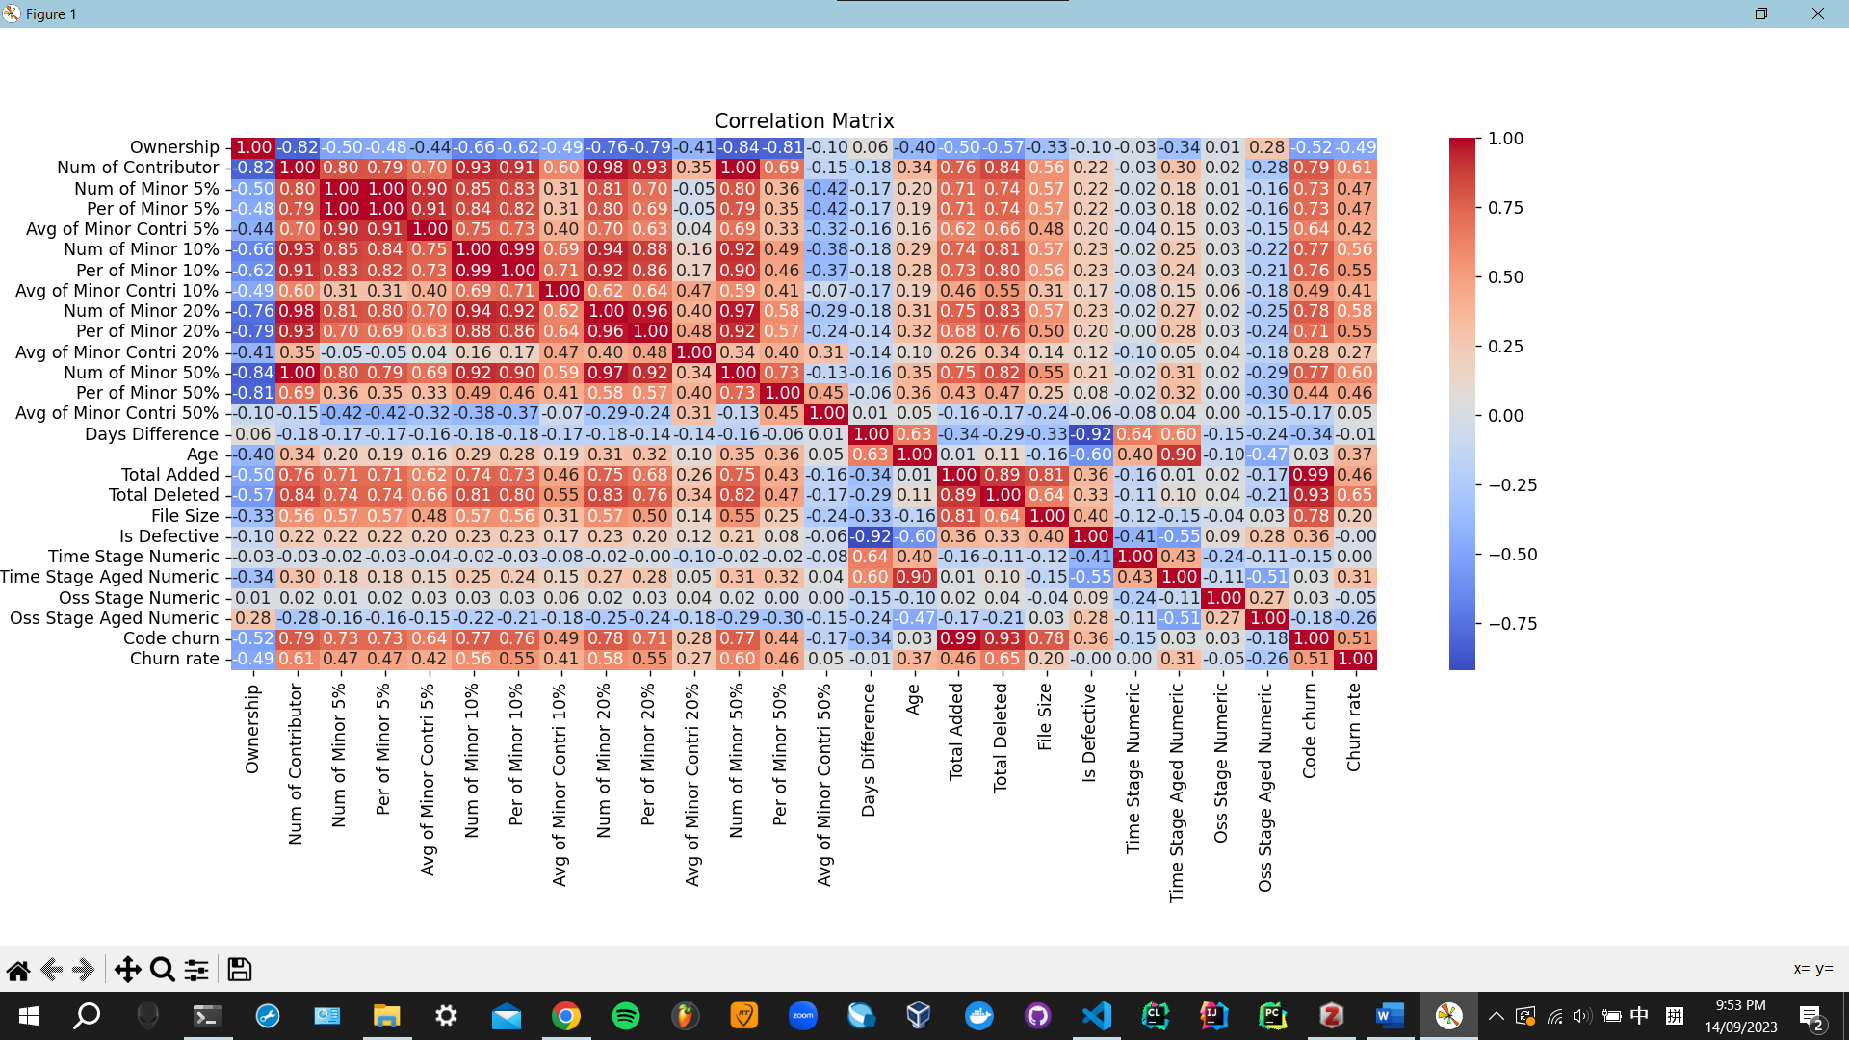

# Vulnerable (vs Age/Time)

Pytorch + tensorflow

## Heatmap (Pearson)

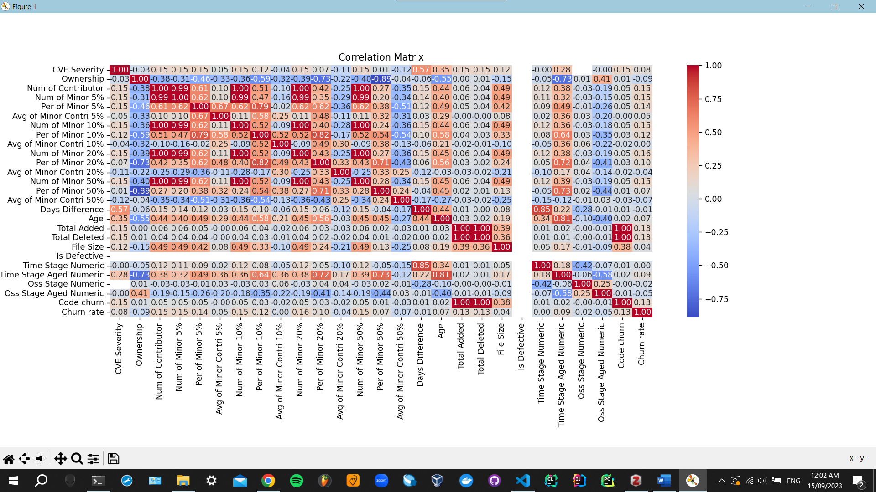

## Heatmap (Spearman)

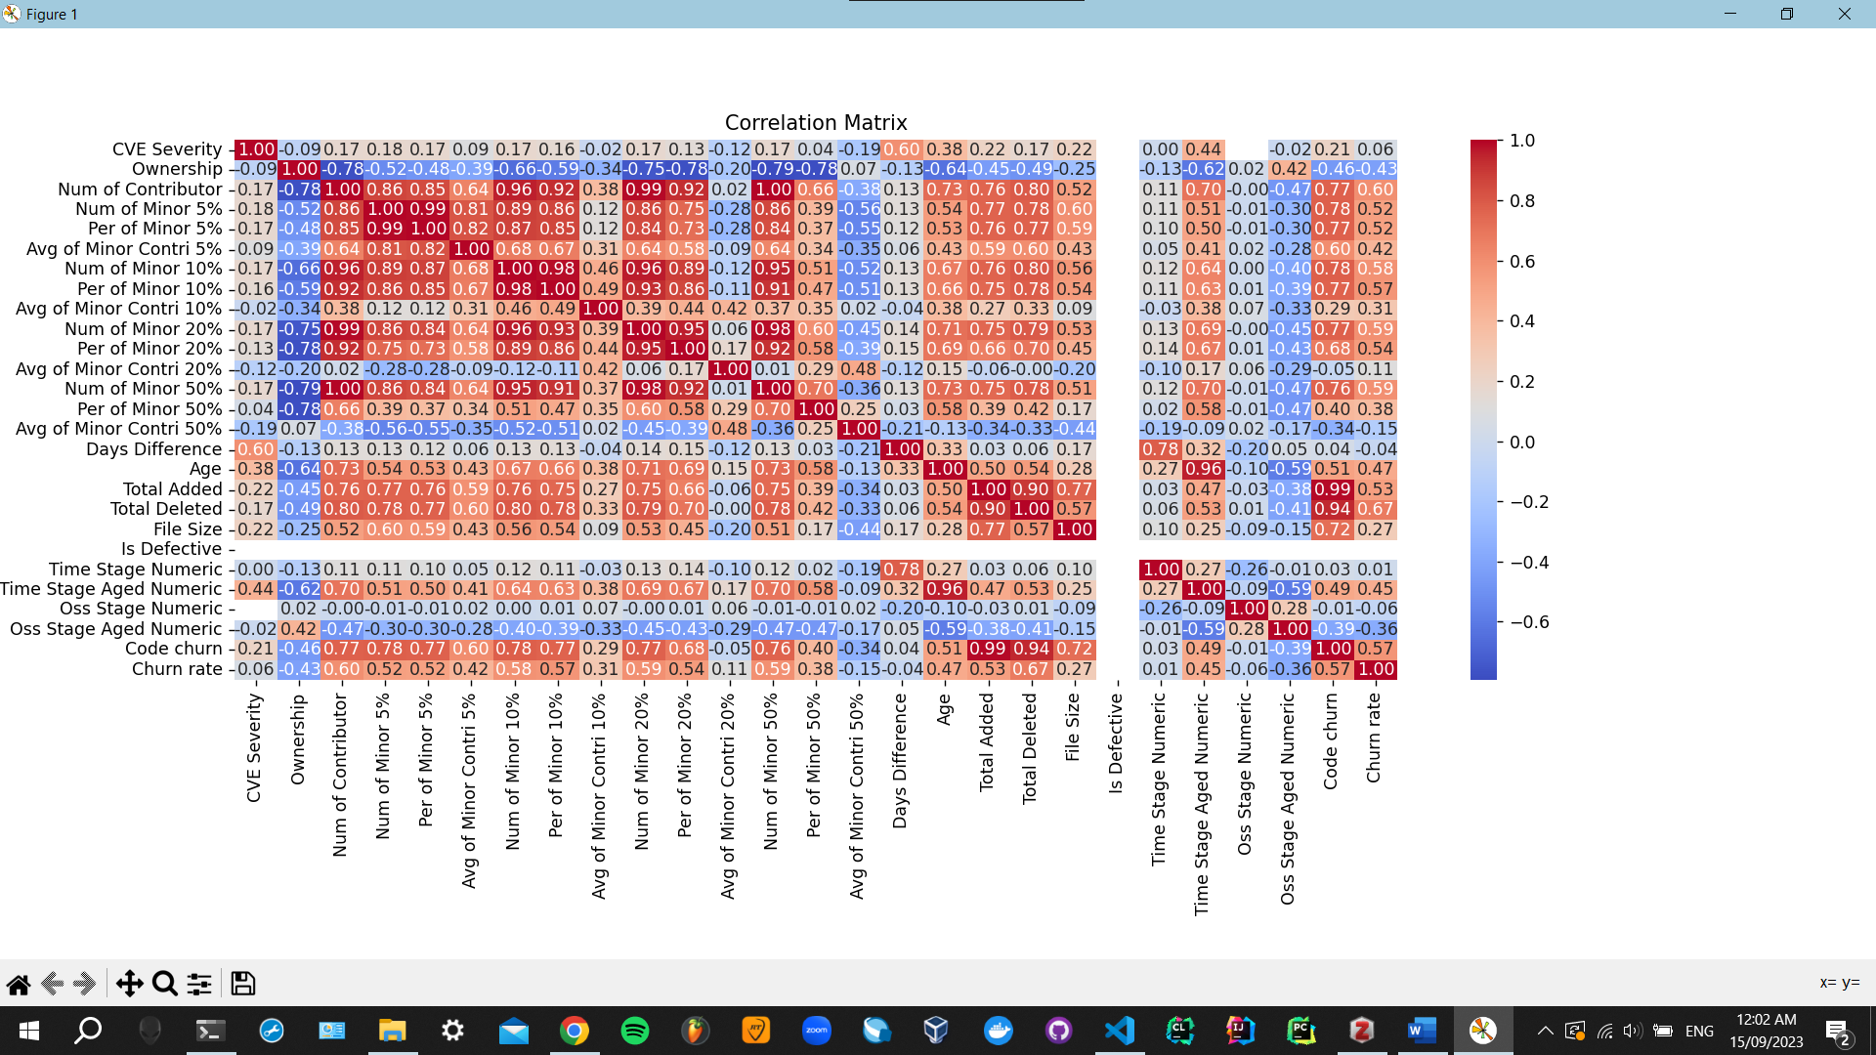

## Multiple Linear Regression

### Classic

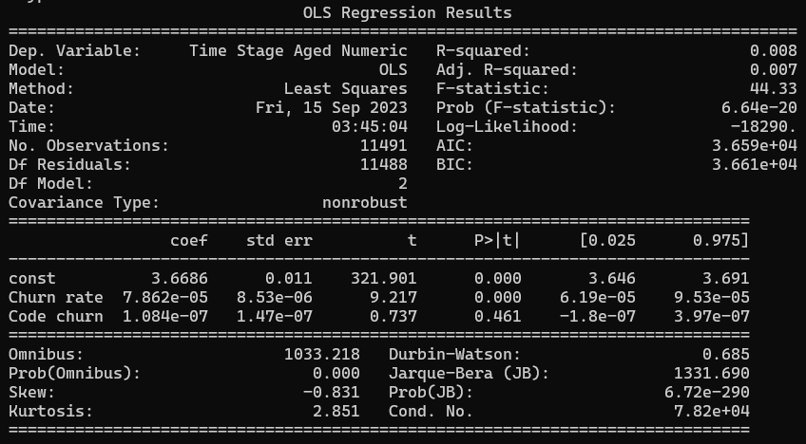

### Classic + Minor

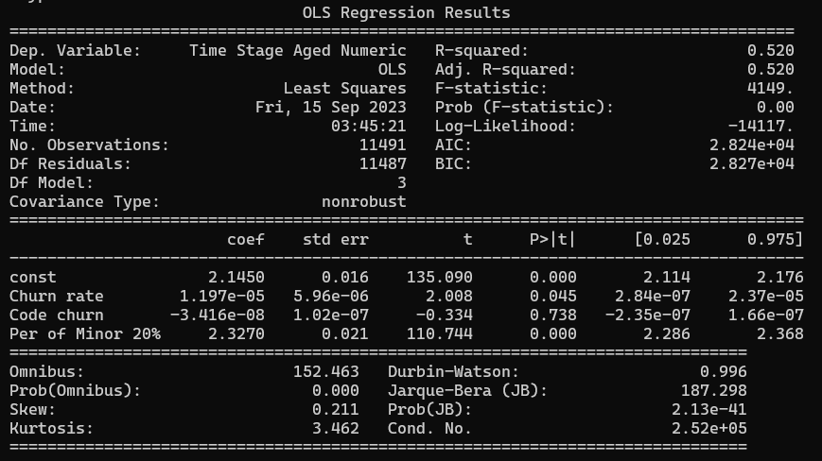

# CVE Severity

NVD official

## Heatmap (Pearson)

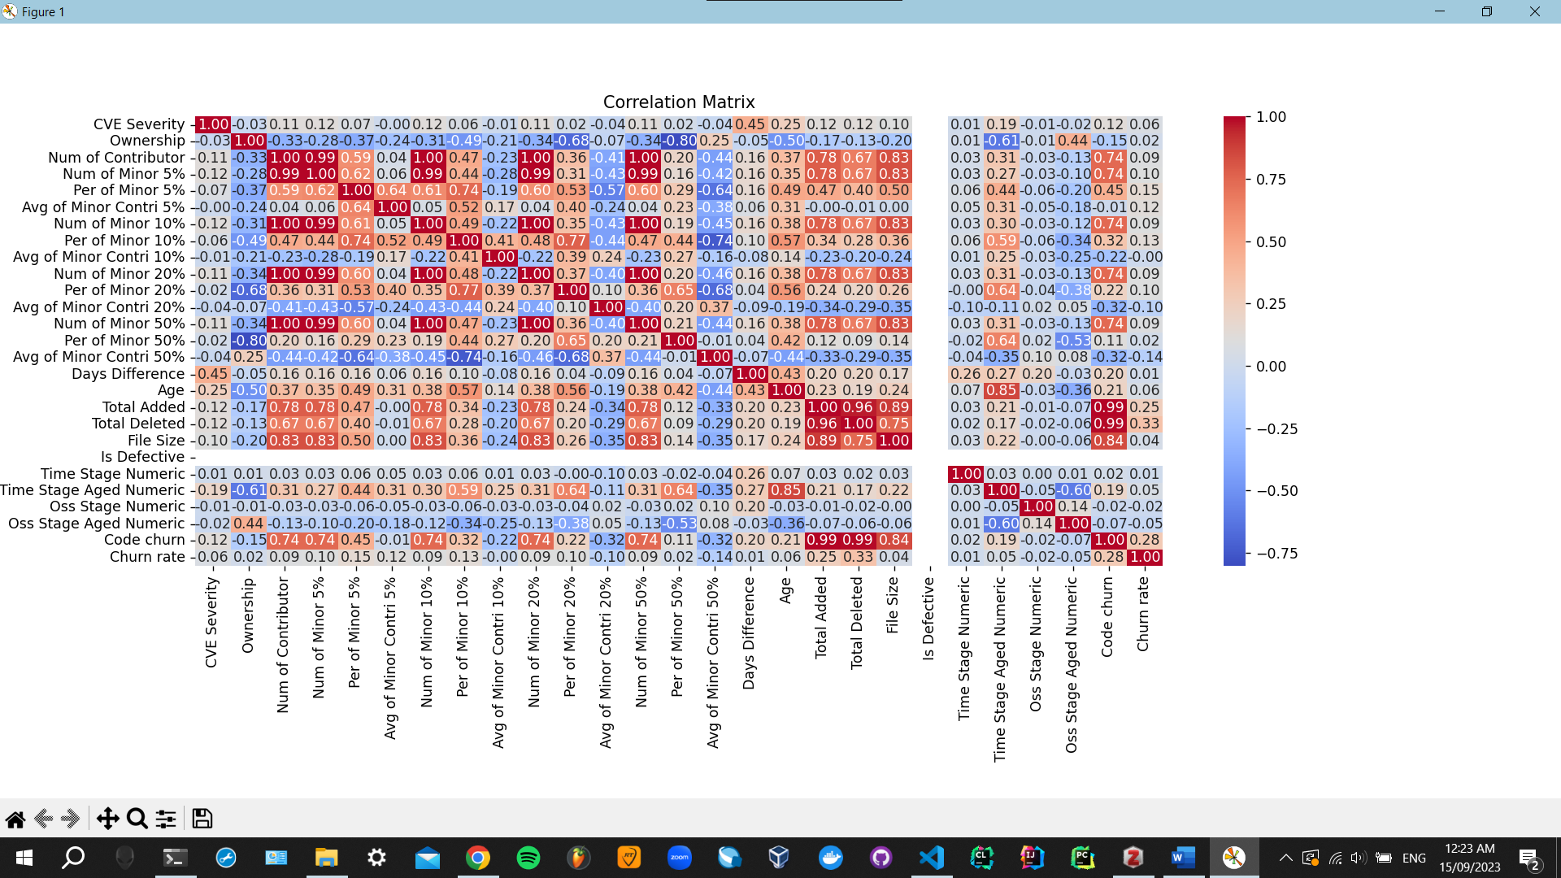

## Heatmap (Spearman)

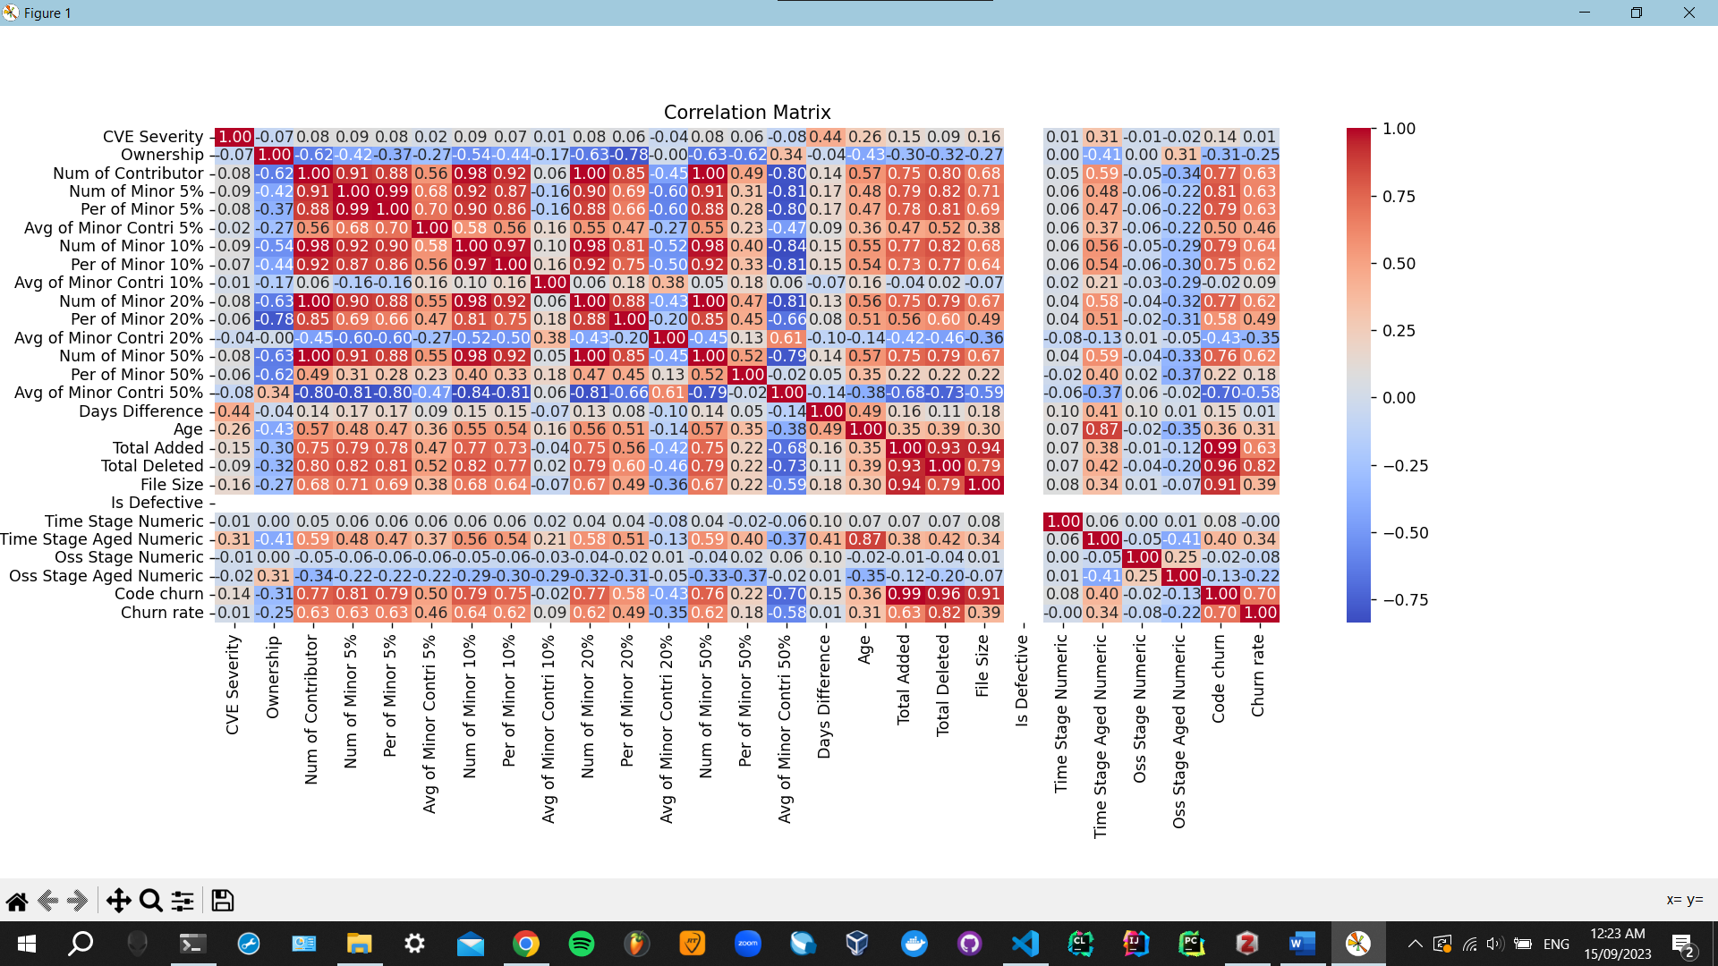

Threshold

Component Type

Prediction